A GUIDE TO THE OUTCOME MAPPING
LEARNING COMMUNITY WEBSITE

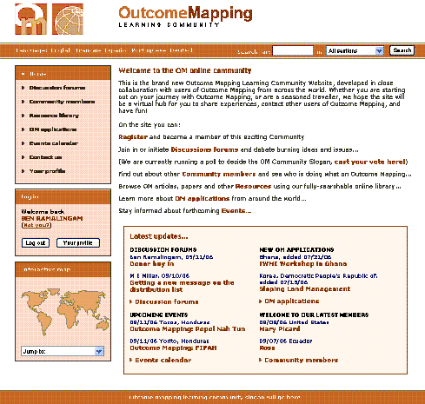

VERSION 1, OCTOBER 2006

Introduction

This is a step-by-step guide for members of the new Outcome Mapping Learning Community website.

It covers the following key functions:

- Updating your user profile pages and community map locations (p2)

- Updating your forum settings e.g. if you want to subscribe or unsubscribe to specific lists (p3)

- Participating in the discussions both via the website and via email (p5)

- Using and updating the Resource Library (p6)

- Using and Updating the OM Applications database (p9)

- Using and Updating the OM Events database (p12)

- Using the Enquiries function (p13)

Do print it off and keep it handy for when you are using the OM Community website.

And of course, as always, your ideas for improving this document, and any feedback are warmly welcomed.

Many thanks,

The OM Community Stewards
October 2006
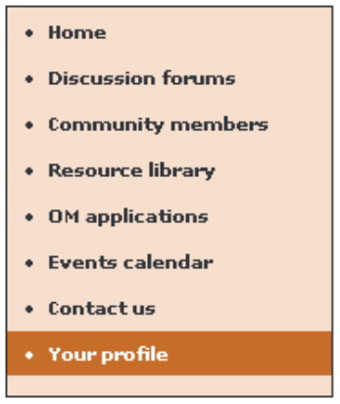
1 Updating User Profiles

To update your profile, you must be logged in. If you attempt to update your profile when not logged in, you will be asked for a username and password.

Log in the normal way, and click on “Your profile” from the left menu. This will load the “YOUR PROFILE” page and give you access to various personal settings that you can change about your profile. The current values for each setting will be in the box next to its name. To change a setting, click on the text box and type in the new value.

Please note:

- Email Address, Country and Region have a * next to their names. This is because these are required fields. Please make sure that these are set correctly as they are important. Failure to set them will result in an error.

- To change your password, type your new password in the “Change your password“ and “Confirm new password” boxes. These two passwords must match otherwise an error will be returned.
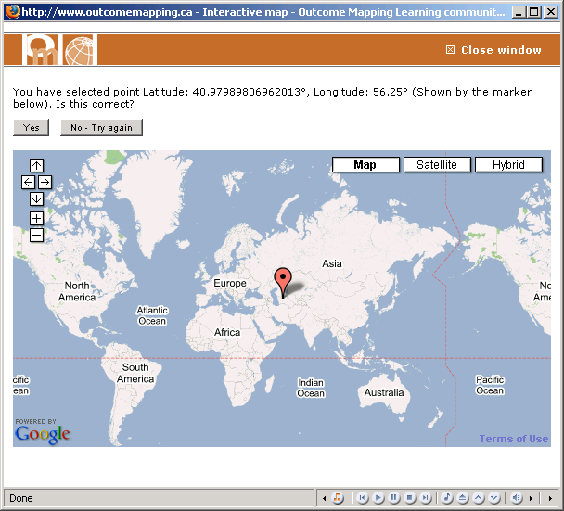
- To change your position on the map, click on “Change your position on the map“. (This will “pop-up” a window, so make sure that any pop-up blockers you have allow pop-ups from all of the “outcomemapping.ca” domain.) This will bring up the map window. Use the “+” and “-” controls to zoom in and the arrows to move around ('dragging' the mouse will move you around the map as well). When you reach your location, click once with the left button and the marker will appear. Once the marker appears, you can click the “Yes” button to confirm placement, or “No” to clear the marker and start again.

- To amend your forum details, click on the “Change your forum settings“ or the “Change your email subscriptions“ link. See below for details of these.

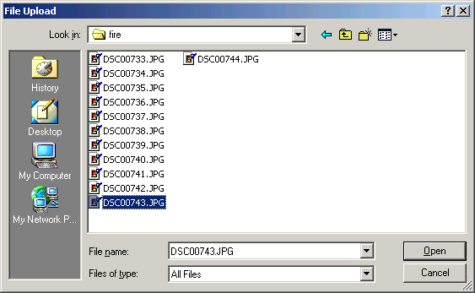
- To upload a photo, click on the “Browse” button next to the “Change your photo“ text box. This will bring up the standard “File Upload” dialog. Navigate to the location of the photo on your computer, and double click the file name. The “File Upload” dialog should vanish and the “Change your photo“ text box should be populated with the location of the photo. The file will be uploaded when “Update Profile” is clicked. IMPORTANT: When you are finished, scroll to the bottom of the page and click on the “Update Profile” button at the bottom.

2 Updating forum settings
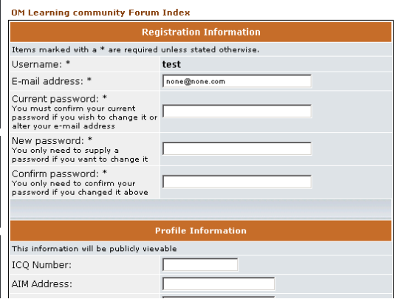
When you sign up to become a member of the Outcome Mapping Learning Community, you are automatically subscribed to the main discussion board used for community interactions. Because of the way the site had to be designed, your settings for the forum are stored on a separate system to the community specific details. But you can access and modify these settings via your user profile page. If you want to modify these, click on the “Change your forum settings“ link. This will bring up the forum's user profile page. Again, please make sure that your email address is correctly inserted here, otherwise you will not receive messages from the forum. To change your password, type in your current password into the box provided and then type your new password into the “New password:” and the “Confirm password:” boxes. This is not necessarily the same as your Outcome Mapping password. Though you can set them to the same thing, if you change one, it will not change the other. When you have finished typing your new forum details, scroll to the bottom of the page and click “Submit”. You can then close the window to return to the main site.

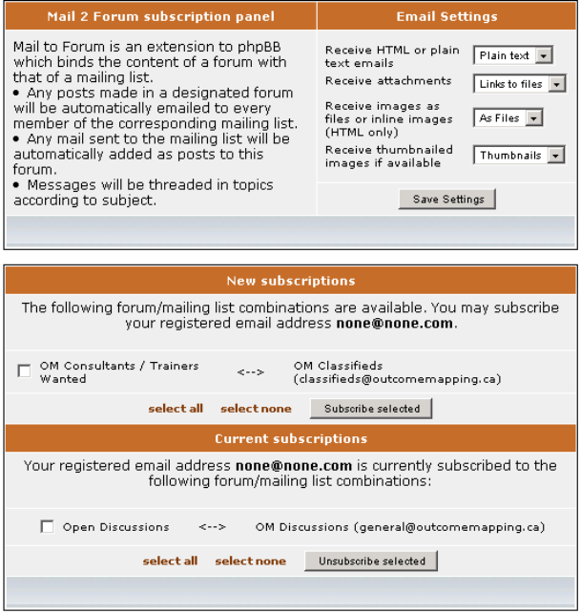
- To select how you receive and submit emails to the forum, click on the “Change your email subscriptions“ link. This is in two sections. The first section deals with that aesthetics of how you prefer to receive and view emails. Make your selections from the drop down lists and then click “Save Settings”.

- The second section of the email subscription preferences deals with which forums you want to be able to send and receive emails to and from. If you are subscribed to a forum, then you can send and receive emails to it. Any forums which you are not subscribed to will appear in the “New subscriptions ” list. If you wish to subscribe to a new forum, click its check box. When you have completed your subscription changes, click “Subscribe selected”. Conversely if you wish to unsubscribe from any forums, look at the “Current subscriptions ” list and mark any forums that you wish to unsubscribe from. When you have completed your unsubscription changes, click “Unsubscribe selected”.

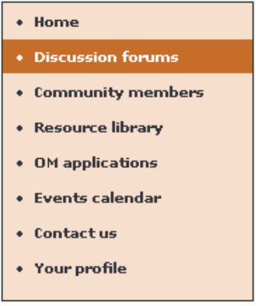
- Participating in discussions

The Outcome Mapping Learning Community forum is built on the popular phpBB forum package (http://www.phpbb.com/), with the attachment and Mail 2 Forum extensions.

To access the forums, click on the “Discussion forums” link from the left-hand navigation area. This will take you to the main forum area. At the top is a menu, and below that there is two boxes, the forum list and the “Who is Online” box. The forum list contains the list of Outcome Mapping forums that have already been set up. If you wish to view one of these, click on the forum name and you will be taken to the topic lists for that forum.

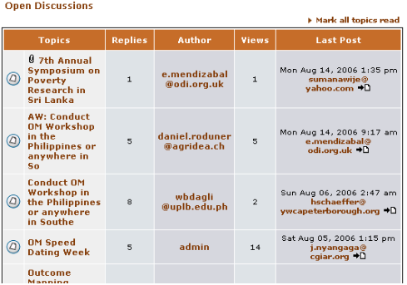
Posting messages from the OutcomeMapping.ca website

Once you have accessed the topic list for your chosen forum you will see the list of most recent topics posted to it. You may start a new topic, by scrolling to the bottom of the topic list and clicking the “new topic” button. This takes you to the new message page. Click on the “Subject:” box and type in the subject for your new topic. Then click on the main message box and type in your message. You can use the buttons provided above the message box to format and add hyperlinks to your message, for ease of reading.

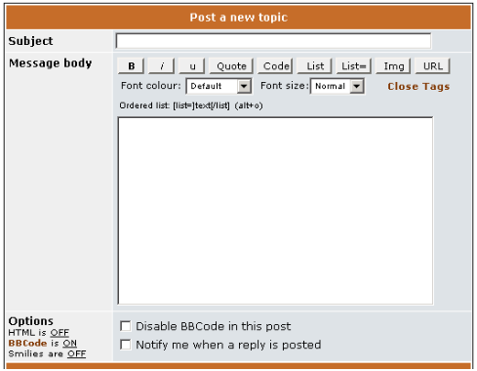
If you want to reply to an existing topic, from the topic list, click on the subject line of the topic you wish to reply to. This will take you to the message list for that topic. At both the top and bottom of the message list there both the “new topic” and “post reply” buttons. “new topic” button will open a new topic in the forum, as described above. The “post reply” button will add a new message to an existing topic. When you click on the “post reply” button the “compose message” page will appear. The subject line is less important here, so you can click straight to the message window and type your reply.

Posting messages by email

You can reply to any topic by email, from which you have received an email. If you have chosen to receive email from a forum, you are said to have “subscribed” to it. You can choose which forums to subscribe to from the user profile page (See section 1 of this document).

You will receive notification emails of new posts to topics in forums you are subscribed to by email as soon as the post was posted. To post to this topic, you can simply reply to this email. The post will be added to the topic as soon as the mail server processes your email.
IMPORTANT: Note that if you reply to an email, the system automatically assumes you are responding to the ongoing topic. If you want to start a new discussion topic, you must make sure to create a new email and send it to the address of the board of your choice. This is important for the ensuring there is a seamless integration of the email and the web-based forum.
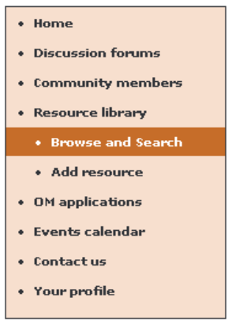
- The Resource Library

The resource library is a store for documents pertaining to Outcome Mapping's various activities. Any member is welcome to add resources to his profile. These will then be publicly visible and ratable by other users. To access the resources area, click on “Resource library“ from the left hand navigation menu.

Adding a resource

Click on the “Add resource” sub menu item of the left hand navigation area. This will load the “Add resource” page.

You must first choose the document theme from the list of themes in the drop-down list. Choose the one that most closely matches your new resource. This is a required field and failure to choose one will result in an error.

Then choose a theme for the document. Similarly, this must be chosen from a list and is a required field.

Then choose up to four authors for the document. These again must be chosen from a list of all users of Outcome Mapping. This is not a required field, and the names of any authors of the document who are not also members of Outcome Mapping, can be typed into the “Other author(s)” text box.
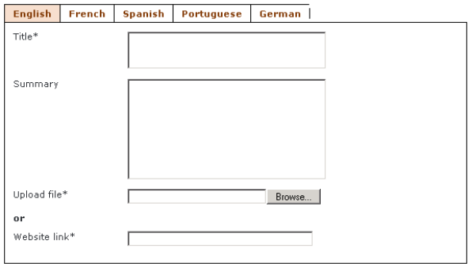
Then you can type in some specific details for the resource in the language-specific boxes. “Title:” is a required field. Although “Summary:” is not, what you type here will help to make to document more locatable to those searching for it, so it is helpful to type something there.

Next you must either:

- Upload the document from your machine, by clicking on the “Browse” button and navigating using the “File Upload” dialog to the file, located on your computer. Double-click on the file name and the dialog will disappear and the “Upload file:” text box will be filled with the path to the file.

Or:

- Type or paste the Web address of the document in to the “Website link:” text box. This is used only if the document is not on your machine, but somewhere else on the internet, but it is still useful to Outcome Mapping.

Note that you must fill in one of these fields; otherwise an error will be returned.

You may add different language versions of the document, by clicking on the language name in the tab at the top of this box. Clicking on another language name will not erase any of the data you have already typed, you can click back to the first language and the data will re-appear. For subsequent languages, type in a new Title and Summary in this language and point to the version of the same document, in this language, in the same way as described above.

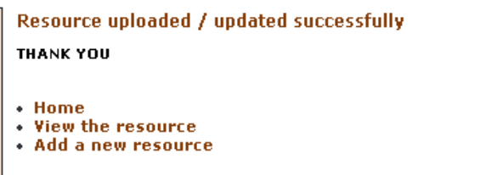
If you wish the document to be translated by a translator, you can mark the “Request Translation” checkbox. Once you have set all the fields and pointed to all the versions of the document, in each language you are able, click the “Upload resource” button. Please only click it once though - this process may take some time, if you have many versions of a document, or it is large. You will be prompted when the process is finished.

Locating and viewing a resource

Select the “Resource Library” from the left hand navigation area, then click on the “Browse and search” sub menu item of the left hand navigation area, if it is not already selected.
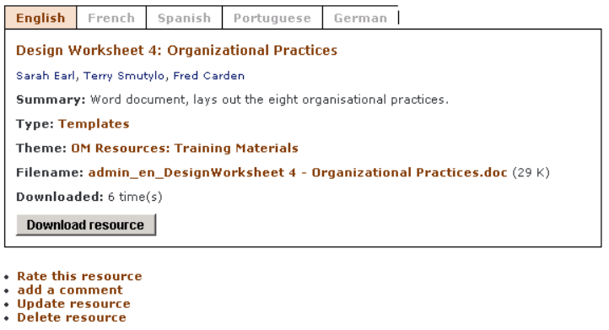

If you know exactly the theme and type of the document, it may be quickest to browse for it. Click on either the correct theme or type name, from the lists on the page. All the documents in the selected type or theme will be displayed. Select the one you want, and click on its title. You will be presented with the “View Resource” page (illustrated).

Alternatively, you can search for a resource. You can search on the following parameters:
- Free text: If Outcome Mapping was successfully able to extract the text from the document, you can search on the actual document’s text.
- Title & Summary: Search on the title and summary input by the user who created the resource
- Theme & Type: Search on the theme or type, chosen by the user who created the resource
- Author: Search on one of the authors, chosen by the user who created the resource.
- Only show results in: Select one language in which documents must have been written

A successful search will return a list of subjects of matching documents, followed by summary, type and theme. Click on the subject and you will be presented with the “View Resource” page (illustrated).

Updating a resource

Navigate to the “View Resource” page of the document you wish to update. Underneath the resource details is a small menu. From this menu, click on “Update resource”. You will be presented with the “Update resource” page. This is identical to the “Add resource” page, except some of the fields are filled with the current details of the resource. Modify the ones that need to be changed and click the “Update resource” button. For more information on this page, see section (3) (a).

Photos and Images as resources

You can add photos and images as a resource in the same way as any other resource. Outcome Mapping treats them both as images. When adding a photo or an image, it is usual to select “Images” from the “Type” drop down box on the “Add resource” page.
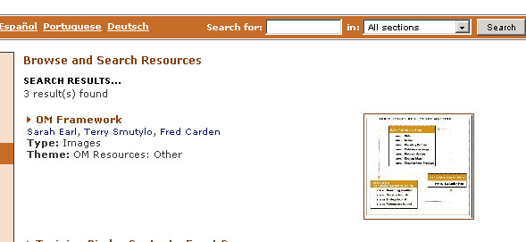
All images and photos will then have a thumbnail shown beside their entries in search results, and on the
“View resource” page.

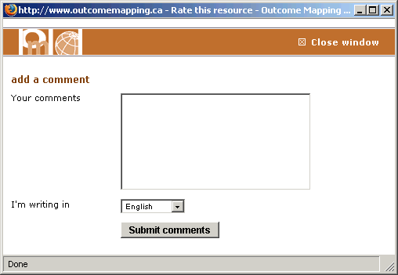
Commenting resources

From the "view resource" page, (see (3) (b)) you can both comment on and rate the usefulness of that resource. To write a comment, select "add a comment" from the menu below resource details. This will open the "Add comment" window, so make sure any pop-up blockers are turned off. In the "Add comment" window, you can type in your comment, and select the language in which the comment is written. Click "Submit comments" when you are done.

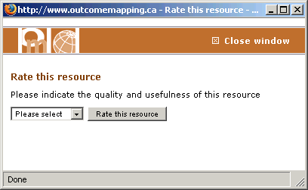
Rating resources

From the "view resource" page, (see (3) (b)) you can both comment on and rate the usefulness of that resource. To write a comment, select "Rate this resource" from the menu below the resource details. This will open the "Rate this resource" window, so make sure any pop-up blockers are turned off. In the "Rate this resource" window, select from the list the description which best described how useful the resource has been for you. Click "Rate this resource" when you are done.
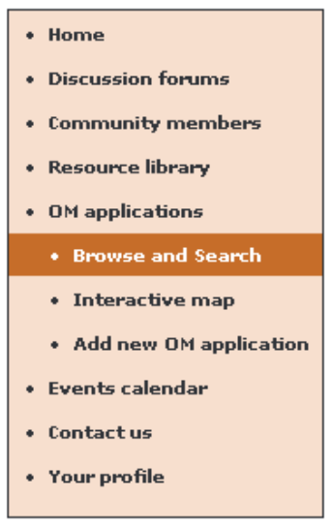
4 Outcome Mapping Applications

Applications are descriptions of projects throughout the world that Outcome Mapping is involved in. Any member is welcome to add applications. These will then be publicly visible by other users. To access the applications area, click on “OM Applications“ from the left hand navigation menu.

Adding an application

Click on the “Add new OM application” sub menu item of the left hand navigation area. This will load the “Add new OM application” page.

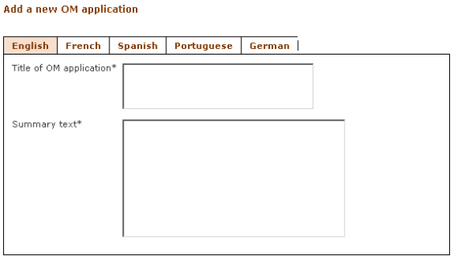
You first add the title and the summary of the application in the boxes provided. You may add different language versions of the document, by clicking on the language name in the tab at the top of this box. Clicking on another language name will not erase any of the data you have already typed, you can click back to the first language and the data will re-appear. For subsequent languages, type in a new Title and Summary in this language.

Below the language tabs, there are some language-independent fields to fill in (Nearest town/city, Area, etc). Note that from these, Country and Region are required fields and must be chosen from the drop-down list; otherwise an error will be returned.

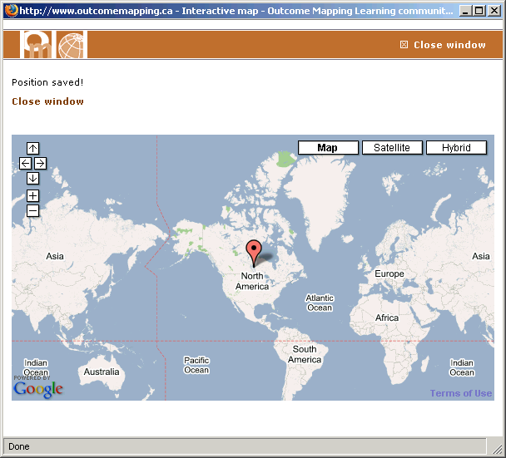
You can add your application to the map from this page. Click on the “Add your OM application to the map” link to do this. This will open the "Interactive map" window, so make sure any pop-up blockers are turned off. In the "Interactive map" window, use the “+” and “-” controls to zoom in and the arrows to move around ('dragging' the mouse will move you around the map as well). When you reach the location of your application, click once with the left button and the marker will appear. Once the marker appears, you can click the “Yes” button to confirm placement, or “No” to clear the marker and start again. When you click yes, the confirmation page will appear, and you can close this window and resume detailing your application.

Once you have finished inserting the details for your application, and added it to the map, click "Add a new OM application" when you are done.

Locating an application

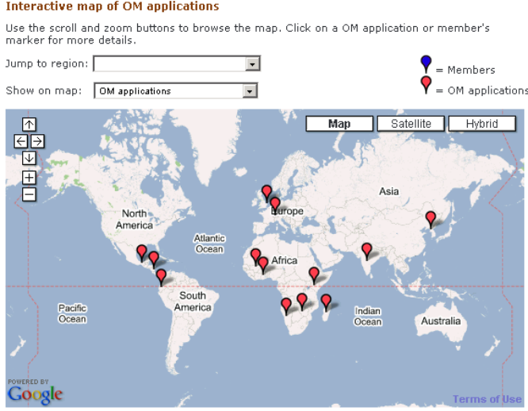
Select the “OM applications” from the left hand navigation area, then click on the “Browse and Search” or the "Interactive map” sub menu item of the left hand navigation area, if it is not already selected.

If you know the location of the application, you can use the interactive map. Click on the "Interactive map of OM applications" link to do this. This brings up the interactive map of the world, with each application marked with a red marker. (You can zoom to a particular region using the "Jump to region:" drop-down list.) Click on one of the red markers to view a balloon with the title and location of the project. Click on either the title or the "View OM application" link to go to the view application page.

Alternatively, from the "Browse and search" page, you can browse the applications, by the region they are based in. Click on the region name in the "BROWSE OM APPLICATIONS BY REGION" area. All the applications in the selected type or theme will then be displayed. Select the one you want, and click on its title. You will be presented with the “View application” page (illustrated).
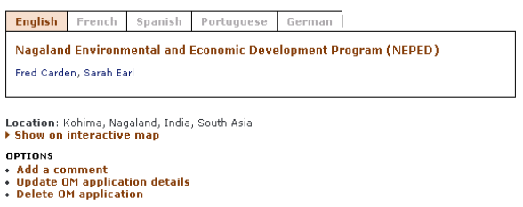

Alternatively, from the "Browse and search" page, you can search for an application. You can search on the following parameters:
- Free text: Any text within the application.
- Title of OM application & Word(s) in summary: Search on the title and summary input by the user who created the application.
- Organisation(s), Donor(s), Nearest town/city & Area.
- Country & Region: Choose the country or region from the drop-down lists.
- Only show results in: Select one language in which documents must have been written.

A successful search will return a list of titles of matching applications, followed by the Outcome Mapping members that are associated to it, followed by country and region. Click on the title and you will be presented with the “View Resource” page (illustrated above).

Updating an application

Navigate to the “View Resource” page of the document you wish to update. Underneath the resource details is a small menu. From this menu, click on “Update OM application details”. You will be presented with the “Update resource” page. This is identical to the “Add new OM application” page, except some of the fields are filled with the current details of the application. Modify the ones that need to be changed and click the “Save changes” button. For more information on this page, see section (4) (a).

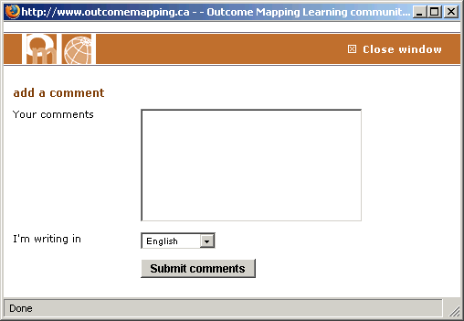
Commenting on an application

From the "view application" page, (see (4) (b)) you can comment on that application. There is a menu below the application details. To write a comment, select “Add a comment" from this menu. This will open the "Add comment" window, so make sure any pop-up blockers are turned off. In the "Add comment" window, you can type in your comment, and select the language in which the comment is written. Click "Submit comments" when you are done.
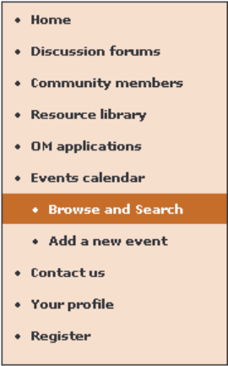
5 Outcome Mapping Events

The Events section can be used to highlight upcoming events which may be of interest to the community. The section is searchable in the same way as the rest of the site. To access the events area, click on “Events Calendar “ from the left hand navigation menu.

Adding an event

Click on the “Add a new event” sub menu item of the left hand navigation area. This will load the “Add a new event” page.

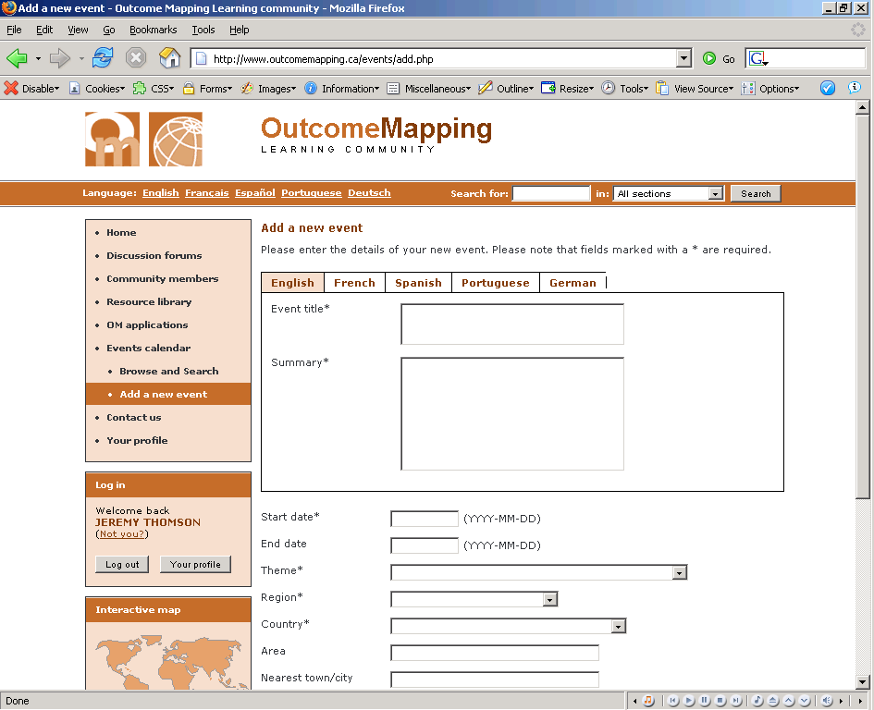
You must first type in some specific details for the resource in the language-specific boxes. Both “Event title” and “Summary” are required fields, so you must specify them in at least one language.

Now you can fill in the other fields, which are language independent. Of these, “Start date”, “Theme”, “Region” and “Country” are required fields and must be entered / selected or an error will result. “Start date” and “End date” must be specified in international date format, with year first, then month, then day. An example is: “1970-01-01” for the 1st January 1970.

“Theme”, “Region” and “Country” are chosen from drop-down lists. For the theme, select the one that most closely matches the theme of your document.

Fill in the rest of the details, (Area, Nearest town/city, website title,…) type in those details which you have. Once you have finished, click the “Upload Event” button to submit your event. If no errors are reported, your event will have been added to the database.

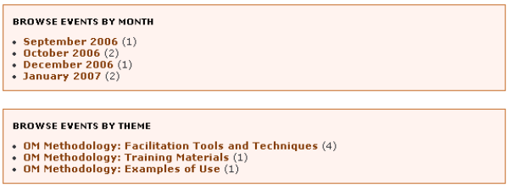
Locating and viewing an event

Select the “Events Calendar” from the left hand navigation area, then click on the “Browse and Search” sub menu item of the left hand navigation area, if it is not already selected. You will be presented with the “Browse and Search Events” page.

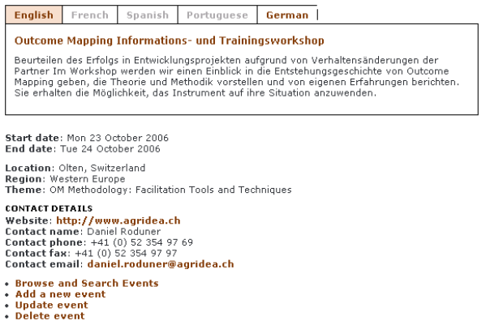
If you know exactly the theme, or the data of the event, it may be quickest to browse for it. Click on either the correct theme or month, from the lists on the page. All the events with the selected theme or in the chosen month will be displayed. Select the one you want, by clicking on its title. You will be presented with the “View Resource” page (illustrated).

Alternatively, from the “Browse and Search Events” page you can search for a resource. You can search on the following parameters:
- Title & Word(s) in Summary: Search on the title and summary of the event
- Starting after / Ending by: Search the range of the dates of the event
- Theme, Country & Region: Search on the theme, country or the region chosen by the user who added the event
- Author: Search on one of the authors, chosen by the user who created the resource.
- Include Expired Events: Select this box if you wish to include events which have already happened
- Only show results in: Select one language in which event titles / summaries must have been written

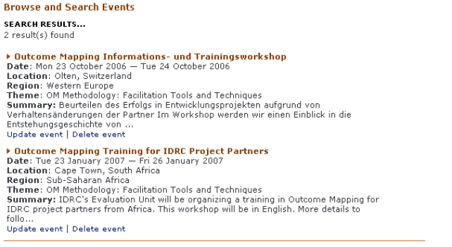
A successful search will return a list of titles of matching events, followed by various details. Click on the subject and you will be presented with the “View Resource” page (above).

Updating an event

Using the “Browse and Search Events” page, navigate to the “View Event” page of the event you wish to update. Underneath the event details is a small menu. From this menu, click on “Update event”. You will be presented with the “Update event” page. This is identical to the “Add event” page, except some of the fields are filled with the current details of the event. Modify the ones that need to be changed and click the “Update event” button. For more information on this page, see section (5) (a).

6 Getting help and making enquiries

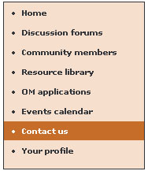
You can ask for help or make enquiries about the Outcome Mapping Learning Community website, by using the “Contact Us” button on the left menu. This will display the “Contact us” page. From here you have two ways of contacting the Technical Steward of the Community:

- Click on the info@outcomemapping.ca link. This will allow you to email the information desk using your preferred email application

- Fill in the web form. You must provide your name and email address here, making sure that you type accurately, otherwise the recipient may not be able to reply. Then you can type your message subject in the “subject” box, and the message itself in the larger “message” box. When you have completed this, press the “Send message” button.

- IMPORTANT: This is part of the website will be soon developed into an OM help desk function, and this section of the guide will be updated at the same time.

